|  |  |
| --- | --- |
| Defect ID | DF001 |
| Tittle | Can’t register with valid data |
| Test Cases ID | TC_001 |
| Reported Date | 03/11/2022 |
| Priority | Medium |
| Status | On Progress |
| Descriptions | When users send POST register requests to the building API, data aren’t register |
| Expected Result | Response Code 200, Success Register |
| Actual Result | Response Code 400, Can’t Register |
| Report to | Back End |

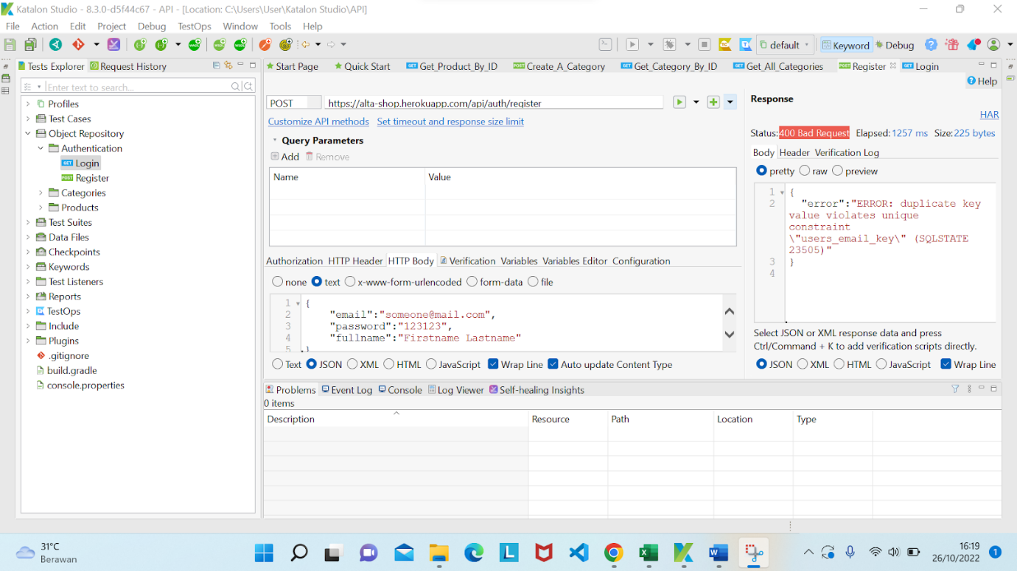

|  |  |
| --- | --- |
| Defect ID | DF002 |
| Tittle | Can login with invalid email |
| Test Cases ID |  |
| Reported Date | 03/11/2022 |
| Priority | Medium |
| Status | On Progress |
| Descriptions | When users send POST login invalid email and send requests to the building API, response code 200, but expected result 400 |
| Expected Result | Response Code: 400 |
| Actual Result | Response Code: 200 |
| Report to | Back End |

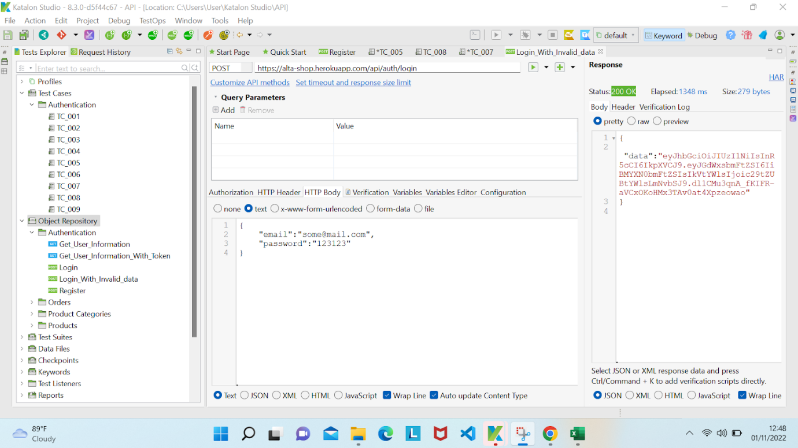

|  |  |
| --- | --- |
| Defect ID | DF003 |
| Tittle | Can create new product without description |
| Test Cases ID |  |
| Reported Date | 03/11/2022 |
| Priority | Medium |
| Status | On Progress |
| Descriptions | When users send POST create new product without description and send requests to the building API, response code 200, but expected result are 400 |
| Expected Result | Response Code: 400 |
| Actual Result | Response Code: 200 |
| Report to | Back End |

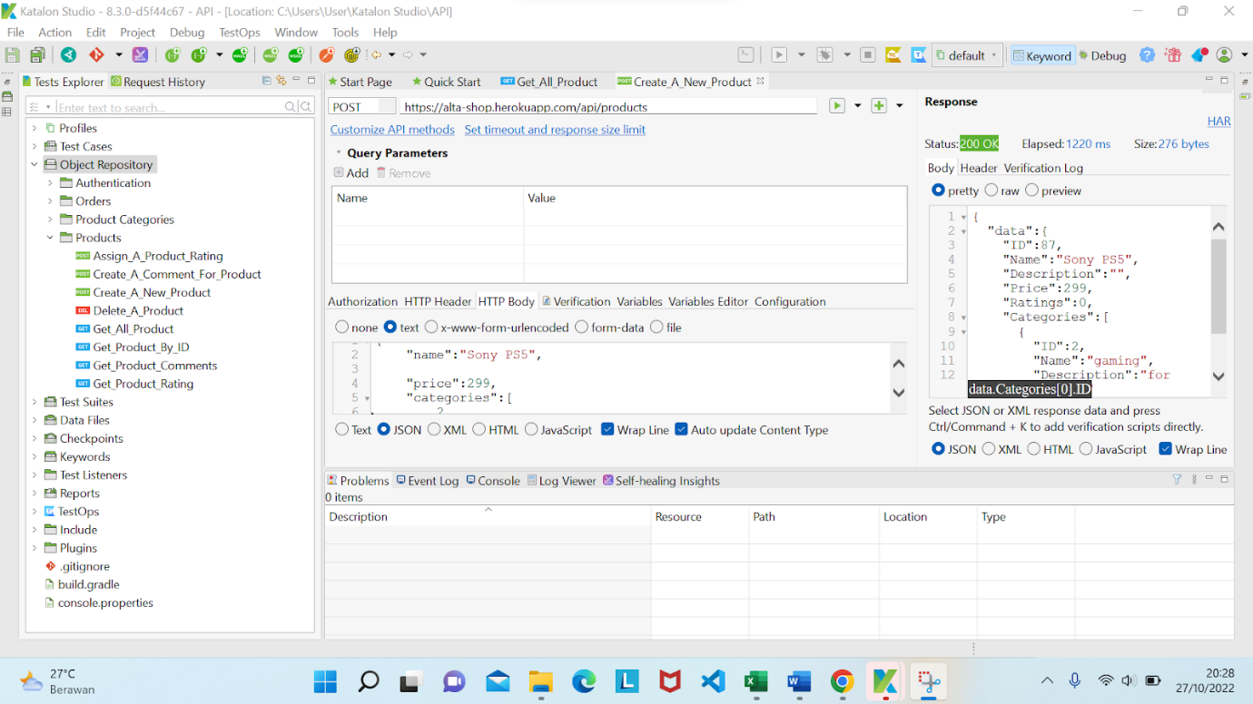

|  |  |
| --- | --- |
| Defect ID | DF004 |
| Tittle | Can delete a product |
| Test Cases ID |  |
| Reported Date | 03/11/2022 |
| Priority | Medium |
| Status | On Progress |
| Descriptions | When users send DELETE a product and send requests to the building API, response code 500, but expected result are 200 |
| Expected Result | Response Code : 200 |
| Actual Result | Response Code : 500 |
| Report to | Back End |

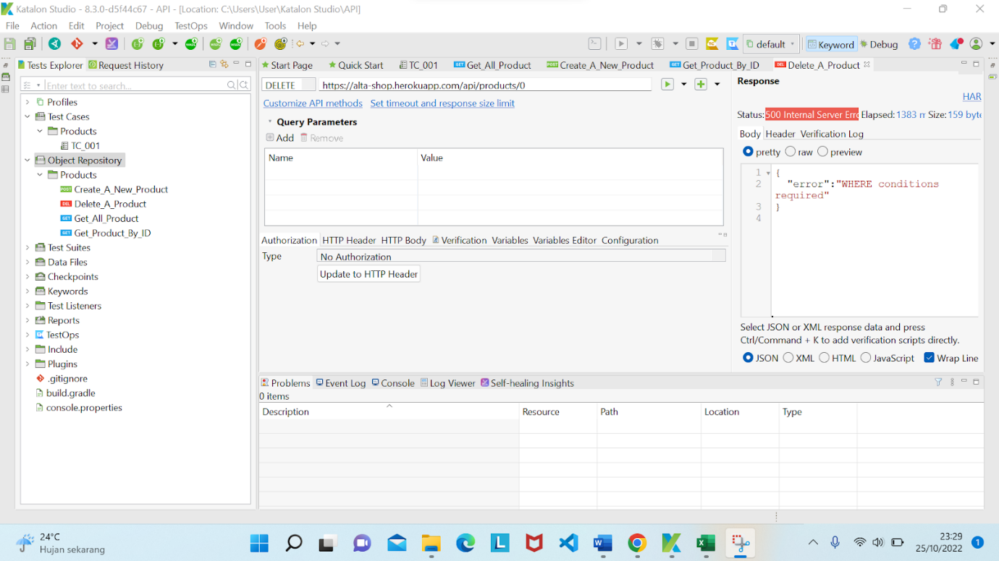

|  |  |
| --- | --- |
| Defect ID | DF005 |
| Tittle | Can create a category with invalid data |
| Test Cases ID |  |
| Reported Date | 03/11/2022 |
| Priority | Medium |
| Status | On Progress |
| Descriptions | When the user fills the register email short password but requirements are fulfilled, and click register button, error invalid password is “password kurang dari 8 karakter” |
| Expected Result | Respon Code : 400 |
| Actual Result | Respon Code : 200 |
| Report to | Front End Web |

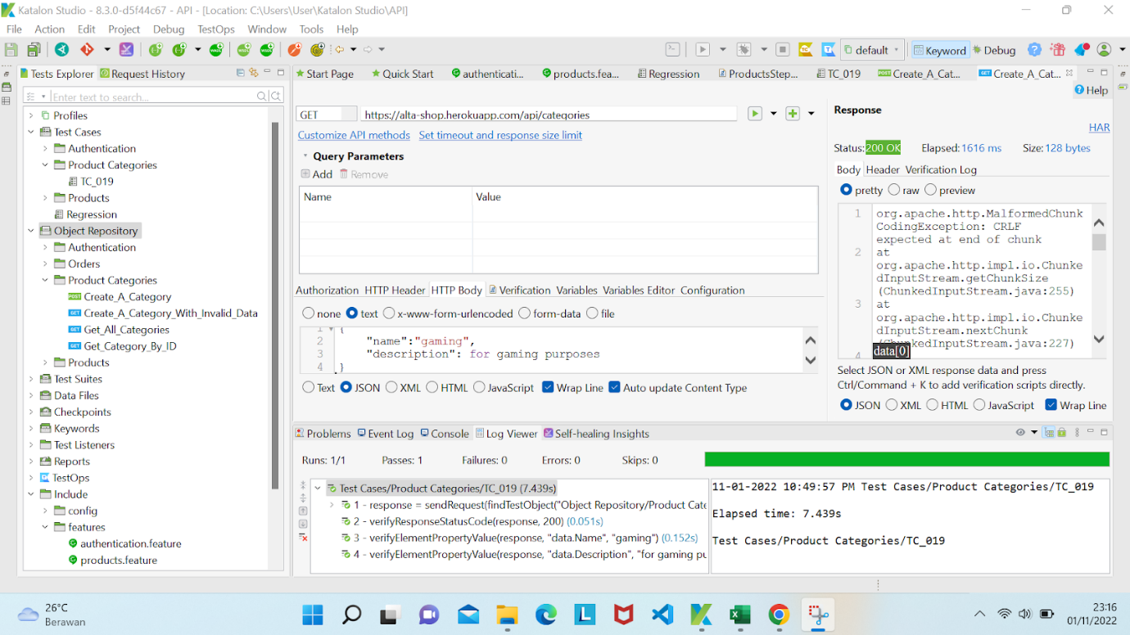

|  |  |
| --- | --- |
| Defect ID | DF006 |
| Tittle | Can registers with invalid email and password |
| Test Cases ID | TC_003 |
| Reported Date | 03/11/2022 |
| Priority | Medium |
| Status | New |
| Descriptions | When the user fills the register email using invalid format, and has successfully registered and navigates to login page |
| Expected Result | Website displays an invalid email message |
| Actual Result | User has successfully registered |
| Report to |  |

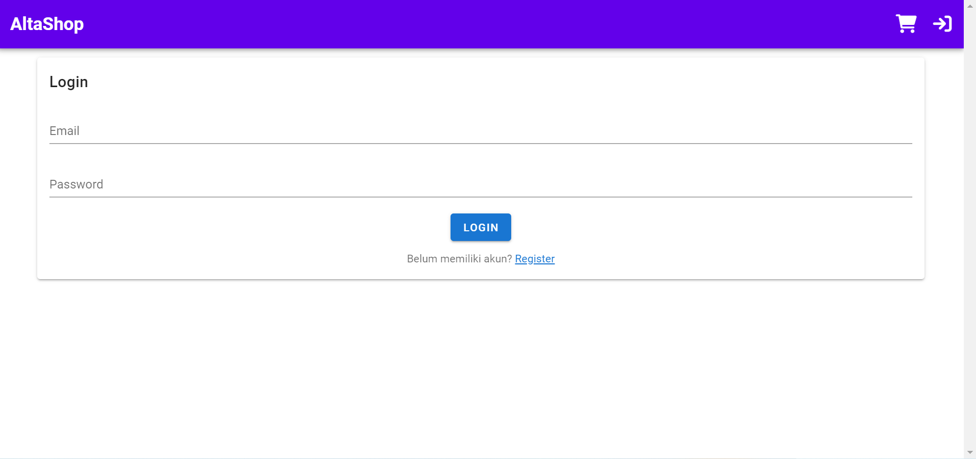

|  |  |
| --- | --- |
| Defect ID | DF007 |
| Tittle | Can login with invalid email |
| Test Cases ID | TC_006 |
| Reported Date | 03/11/2022 |
| Priority | Medium |
| Status | New |
| Descriptions | When the user fills the login email using invalid format, and has successfully registered and navigayes to homepage |
| Expected Result | User can not successfully login |
| Actual Result | User has successfully login |
| Report to | Back End |

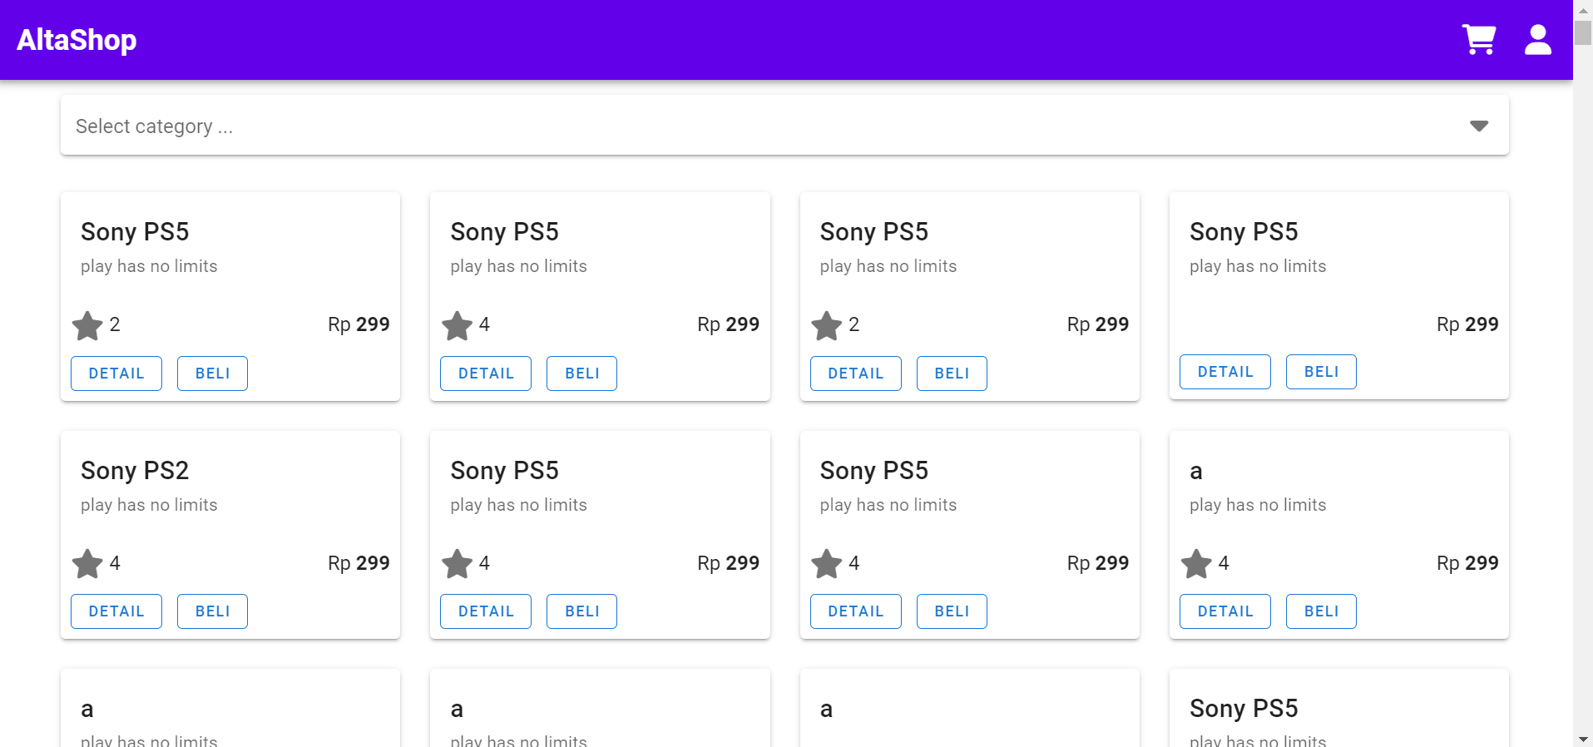

|  |  |
| --- | --- |
| Defect ID | DF008 |
| Tittle | Can give rating product without login |
| Test Cases ID | TC_018 |
| Reported Date | 11/07/2022 |
| Priority | Medium |
| Status | New |
| Descriptions | When user without login, can give rating product |
| Expected Result | Success to give a product rating |
| Actual Result | Rating value is equal to initial rating |
| Report to | Back End |

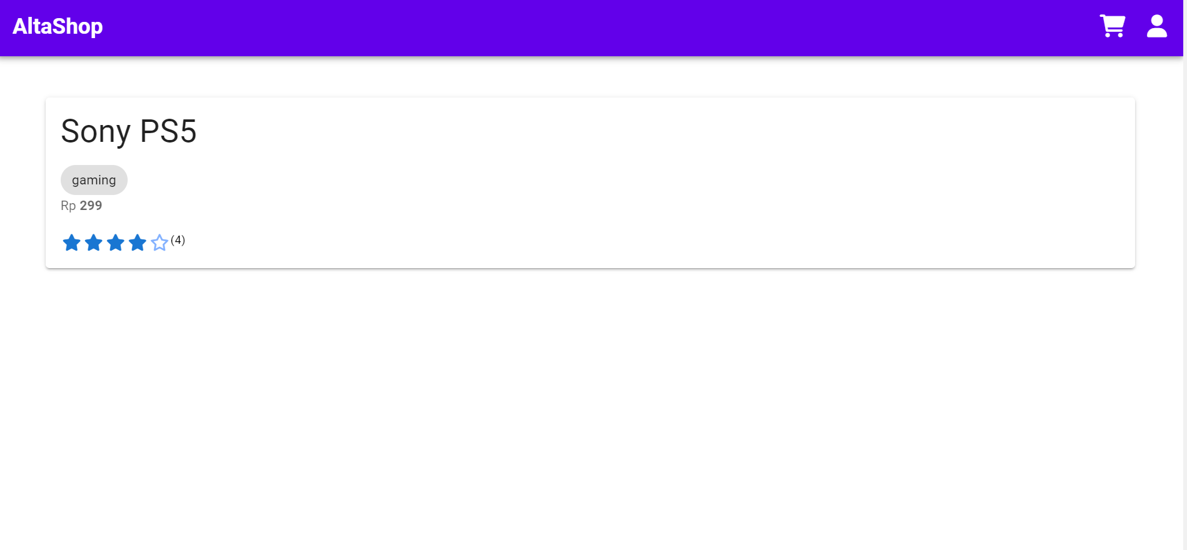

|  |  |
| --- | --- |
| Defect ID | DF009 |
| Tittle | Can change rating product without login |
| Test Cases ID | TC_019 |
| Reported Date | 03/11/2022 |
| Priority | Medium |
| Status | New |
| Descriptions | When user change rating product without login, rating value is equal to initial rating |
| Expected Result | Success to change a product rating |
| Actual Result | Rating value is equal to initial rating |
| Report to | Back End |



|  |  |
| --- | --- |
| Defect ID | DF010 |
| Tittle | Can’t view history transaction |
| Test Cases ID | TC_025 |
| Reported Date | 04/11/2022 |
| Priority | Medium |
| Status | New |
| Descriptions | If you want to see the transaction history, you have to refresh it first |
| Expected Result | Show history transaction |
| Actual Result | Not history transaction |
| Report to | Back End |

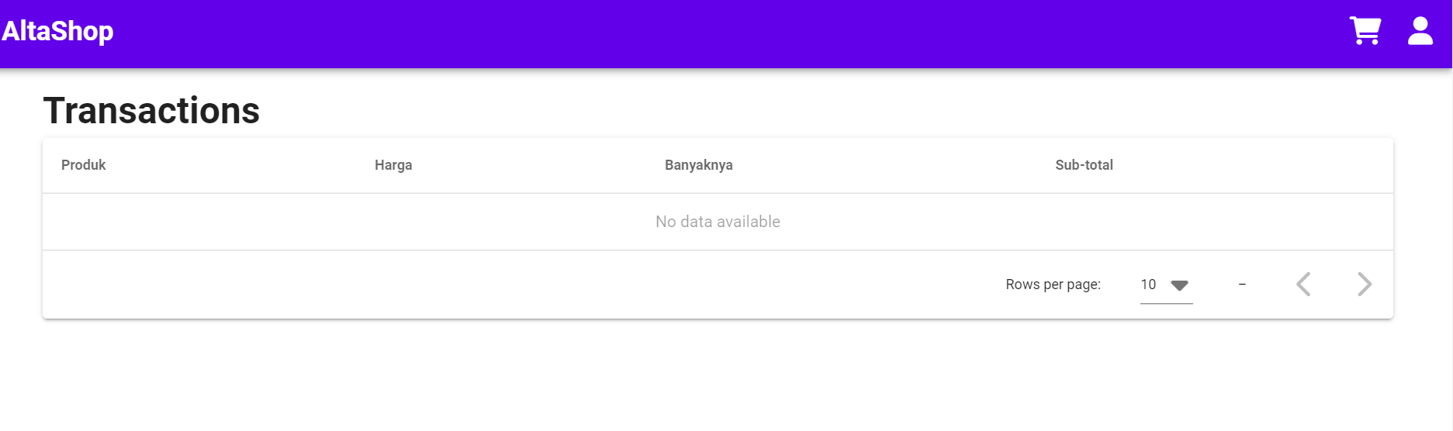

|  |  |
| --- | --- |
| Defect ID | DF011 |
| Tittle | Button cart can't be clicked |
| Test Cases ID | TC_ |
| Reported Date | 04/11/2022 |
| Priority | Medium |
| Status | New |
| Descriptions | If you want to view items in cart, button cart can’t be clicked |
| Expected Result | Show view items in cart |
| Actual Result | Can’t view items in cart |
| Report to | Back End |

